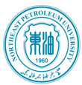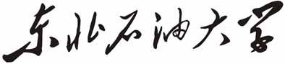
Northeast Petroleum University

在校证明

姓名： ，性别： ，出生日期： 年 月 日，
学号： ，于 年 月入我校
学院 专业 本科学习，学制 年，现为大学 年级学生。
特此证明。

东北石油大学
艺术学院

年 月 日
Northeast Petroleum University

Certificate

This is to certify that Tang Jielin, male, born on July 27th, 1944, has been enrolled as a student majoring in Automation since September, 1999. His student ID number is 88888888, and he is currently studying in the fourth year of four-year educational system in School of Electronics and Information Engineering, Northeast Petroleum University

Northeast Petroleum University
People's Republic of China
November 27th, 2007

